READ ME.MD

Group Alpha

‘Taste of South East Asia’

Prepared by Muhammad Ghaisannaufal Taher (1910331), Delowar Ahmed bin (1825969), Alam Tahmid (1827755), Umir bin Nazaruddin (1912775), and Abyannash Mohammed (1916021)

‘Taste of South East Asia’ is a website to showcase the recipes and history of South East Asia.

1. **Project Description**

Our project is a website that shows traditional, national dishes from each country of the South East Asian region, or more specifically, the countries that are members of the Association of Southeast Asian Nations (ASEAN). For each of these dishes, there will be a recipe page as well as a page that goes into what the dish is, and the history behind said dish. People can register an account in our website.

1. **Project Sitemap**

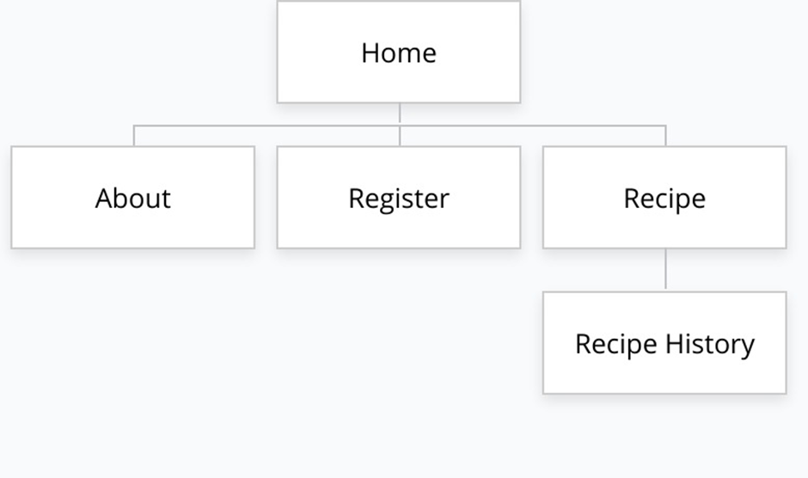

1. **Group Contributions**

Each of the team members prepared 4 web pages for the project as shown in the following table.

|  |  |
| --- | --- |
| **Name** | **Contributions** |
| Muhammad Ghaisannaufal Taher (1910331) | Made the format, design, and content (html and css) of each recipe pages. Made a text box for the user to leave a comment and a simple Javascript that alerts the user that the comment is submitted and will be reviewed by moderators. |
| Delowar Ahmed bin (1825969) | Created the register page, html and css. |
| Alam Tahmid (1827755) | Created the HTML and CSS of the about page |
| Umir bin Nazaruddin (1912775) | Produced a history page for the classic dishes in Southeast Asia whilst focusing on making the page simple yet interesting enough. In addition, added jquery that enables the images to be responsive, touch-enabled, and customisable |
| Abyannash Mohammed (1916021) | My contribution is helping with the website theme, creating the navbar, the homepage and its layout |

1. **Use of third party resources**

|  |  |  |  |
| --- | --- | --- | --- |
| **Web elements** | **Name** | **Use of third party resources and modifications (if any)** | **Modifications (if any)** |
| Interactive images | Fancy apps | Responsive, touch-enabled, and customisableused in the Dish History page | -none- |

1. **References**

Fancy apps. enables the images to be responsive, touch-enabled, and customisable. Retrieved 28 December 2020 from

https://fancyapps.com/fancybox/3/

Pictures for the food used can be found here. Retrieved 26 December 2020 from

<https://sortedfood.com/recipe/chickenadobo>

<https://www.cookingchanneltv.com/recipes/fish-amok-2126612>

<https://riceandkai.wordpress.com/tag/the-food-of-thailand-a-journey-for-food-lovers/>

<https://www.sbs.com.au/food/recipes/pickled-tea-leaf-salad-lahpet-thoke>

<https://glebekitchen.com/pad-thai-rest-us/>

<https://www.simplyrecipes.com/recipes/easy_wok_kissed_beef_pho/>

<http://www.friedchillies.com/recipes/detail/rendang-daging>

https://pixabay.com/photos/food-nasi-lemak-asia-malaysia-658715/

Sources of the recipes used on the website. Retrieved 26 December 2020 from

https://www.gimmesomeoven.com/pho-recipe/

https://tastesbetterfromscratch.com/pad-thai/

https://www.recipetineats.com/filipino-chicken-adobo-flavour-kapow/

https://avocadopesto.com/minced-meat-herb-salad-laap-recipe/

https://www.cookingchanneltv.com/recipes/fish-amok-2126612

https://rasamalaysia.com/beef-rendang-recipe-rendang-daging/

https://rasamalaysia.com/nasi-lemak-recipe/

https://www.196flavors.com/burma-lahpet-thoke-fermented-tea-leaf-salad/